
Kapasa makasa university
Course: soil and water management
Lecturer: Mr Chikuta
STUDENT NAME | STUDENT NUMBER
FRANCISCO ZULU | 20231750
RACHEL SIAKAPONGO | 20231605
CHISHIMBA SYDNEY | 22167595
MICHAEL NGWERE | 20230382
PRISCILLA WINA | 20232049
SARAH MWALE | 20231693
TRIGHT NAKAPITE | 20231925
MLONGOTI COSMAS | 20231586
MARTHA MWINGA | 22180175
DICKSON SHITAH | 22180193

QUESTION
Describe the structure of the earth and its importance in understanding the composition and formation of soils.
DUE
06TH FEBRUARY 2025.

Introduction
The Earth is a dynamic, multilayered system with several layers, each of which is essential to forming the planet's environmental and geological features. Understanding how soil forms and changes over time requires an understanding of the fundamental structure of the Earth. Because it filters water, supports ecosystems, and gives plants nourishment, soil is an essential natural resource that keeps life going. But the geological makeup of the Earth's crust, tectonic movements, and weathering processes that reduce rocks to tiny particles all have a significant impact on soil formation, which is not a random process (Brady & Weil, 2019).
We can better understand the origins of various soil types and their characteristics by knowing the structure of the Earth. For instance, sedimentary activities result in the buildup of organic matter that improves soil fertility, while volcanic activity helps create fertile soils. Furthermore, soil distribution is influenced by climatic patterns and plate tectonics, which has an impact on land management, forestry, and agriculture (Buol et al., 2011). We can create plans to preserve soil, stop erosion, and maximize land usage by researching the composition of the Earth (Brady & Weil, 2019).

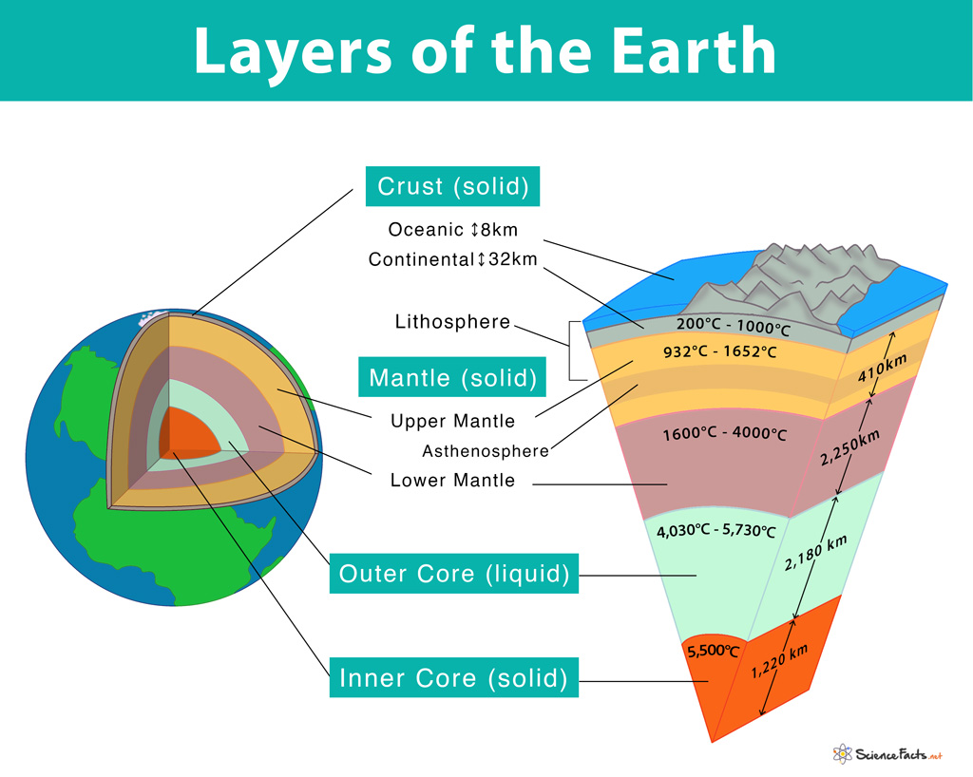

The Structure of the Earth
The Earth consists of four primary layers, the crust, mantle, outer core, and inner core. Each layer has distinct physical and chemical properties that influence geological and environmental processes which includes

The Crust

The Source of Soil-Forming Minerals

Continental Crust
The continental crust is approximately 30 and 50 kilometers thick. Granite, a rock rich in silica (Si) and aluminum (Al), makes up the majority of the SiAl layer. A wide variety of rock types, including volcanic, sedimentary, and metamorphic rocks, are found in this crust and act as the parent material for soil formation. Sandy loams and other granite-derived soils are frequently well-drained but low in nutrients, necessitating organic matter for fertility (Jenny, 1994).
Oceanic Crust
Compared to the continental crust, the oceanic crust is denser yet thinner (5–10 km thick) (Brady & Weil, 2019). It is mostly made up of the SiMa layer, which is basalt, a rock that is high in iron (Fe) and magnesium (Mg). According to Buol et al. (2011), basaltic rock weathers into nutrient-rich soils that are good for plant growth and frequently include high levels of iron and magnesium.
2.The Mantle
Driving Plate Tectonics and Soil Formation
The Earth's thickest layer, the mantle, stretches between 30 and 2,900 kilometers below the surface. Iron and magnesium-rich silicate minerals make up the majority of its composition (Brady & Weil, 2019).

a. Upper Mantle (Lithosphere and Asthenosphere)
The crust and the stiff highest portion of the mantle are both considered to be part of the lithosphere. According to Buol et al. (2011), it is divided into tectonic plates that shift as a result of convection currents in the asthenosphere underneath. A semi-fluid layer called the asthenosphere permits tectonic plate movement, which affects soil formation through earthquakes, volcanic eruptions, and mountain-building processes (Brady & Weil, 2019).

b. Lower Mantle
The high temperature and pressure in this area make it stiffer. Plate tectonics is driven by mantle heat, and orogeny (mountain creation), subduction, and volcanic activity all have an impact on soil distribution (Turcotte & Schubert, 2014).
3.The Core
Indirect Influence on Soil Formation
Iron and nickel make up the majority of the two layers that make up the Earth's core, the outer core and the inner core. Soil creation is indirectly impacted by these layers' effects on Earth's magnetic field, climate, and geological activity (Jenny, 1994).

The Importance of Earth’s Structure in Soil Formation

Weathering Processes and Soil Development
The process that breaks down boulders into tiny pieces to create soil is called weathering. It is divided into three types and is impacted by the geological structure of Earth:
Physical Weathering
This is caused by mechanical forces, temperature fluctuations, and frost action. Frequent in arid, cold climates were rock contraction and expansion lead to fragmentation. The breakdown of rocks into smaller particles through weathering and erosion is influenced by the Earth's climate, topography, and geological processes. Soils are formed through the accumulation and transformation of these particles (Brady & Weil, 2019).
Chemical Weathering
This includes chemical processes that change the minerals in rocks to create clay and other soil constituents. Frequently found in humid areas where carbon dioxide and water combine to generate weak acids that dissolve minerals (Jenny, 1994).
Biological Weathering
This involves the breakdown of rocks by living things like bacteria, fungi, and plant roots. Plant roots provide organic acids that aid in the dissolution of minerals and improve soil fertility (Jenny, 1994).

Conclusion
the structure of the Earth plays a vital role in understanding the composition and formation of soils. The Earth's crust, mantle, outer core, and inner core work together to shape our planet's surface and create the conditions necessary for soil formation. The rock cycle, weathering and erosion, mineral composition, and soil formation factors all contribute to the complex process of soil creation. Soils are a delicate balance of physical, chemical, and biological components, and their formation is influenced by a wide range of factors, including climate, topography, vegetation, and geological processes. Understanding the Earth's structure and processes helps us appreciate the intricate relationships between these factors and how they shape our soil resources. The importance of soils cannot be overstated. Soils support plant growth, filter water, and store carbon, making them essential for maintaining ecosystem health and mitigating climate change. However, soils are facing increasing threats, including erosion, degradation, and contamination, which can have devastating consequences for ecosystems and human societies.
References
Brady, N. C. & Weil, R. R. (2019). The Nature and Properties of Soils. 15th ed. Pearson.
Bronick, C.J. and Lal, R., 2005. Soil structure and management: a review. Geoderma, 124(1-2), pp.3-22.
Buol, S. W., Southard, R. J., Graham, R. C. & McDaniel, P. A. (2011). Soil Genesis and Classification. 6th ed. Wiley.
Dover Publications.
Jenny, H. (1994). Factors of Soil Formation: A System of Quantitative Pedology.
Schaetzl, R.J. and Thompson, M.L., 2015. Soils. Cambridge university press.
Sofo, A., Zanella, A. and Ponge, J.F., 2022. Soil quality and fertility in sustainable agriculture, with a contribution to the biological classification of agricultural soils. Soil Use and Management, 38(2), pp.1085-1112.
Turcotte, D. L. & Schubert, G. (2014). Geodynamics. 3rd ed. Cambridge University Press.

